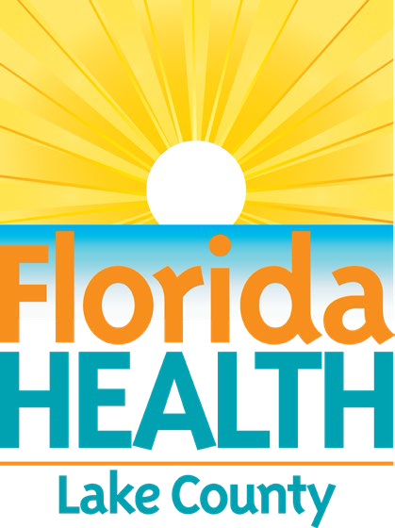March 21, 2025

DOH-Lake Hosts World Tuberculosis Day Event

# Contact:

Noelda Lopez, Public Information Specialist [Noelda.Lopez@flhealth.gov](mailto:Noelda.Lopez@flhealth.gov)

Office: 352-589-6424, After Hours: 352-729-1754

**Eustis, Fla. —** The Florida Department of Health in Lake County (DOH-Lake) invites the community to attend the World Tuberculosis (TB) Day Public Health Educational Outreach event on Monday, March 24, 2025. Educational materials will be available and TB skin tests will be offered for a fee of $50 per test. A TB blood test will also be available for a fee of $70 per test.

The event will be held from 9 a.m. – 1 p.m. at the following location:

# Florida Department of Health Leesburg 2113 Griffin Road

**Leesburg, FL 34748**

TB is caused by a bacterium called *mycobacterium tuberculosis* that usually attacks the lungs, but can attack any part of the body, including the kidney, spine, and brain. Latent TB can live within the body without making you sick. People with latent TB do not have symptoms, are not infectious, and cannot make others sick.

For more information, please contact the Florida Department of Health in Lake County at 352- 771-5500 option 2 or visit the [Department’s website](https://www.floridahealth.gov/diseases-and-conditions/tuberculosis/index.html).

###

# About the Florida Department of Health

The Department, nationally accredited by the exit disclaimer icon [Public Health Accreditation Board](http://www.phaboard.org/?utm_source=floridahealth.gov&utm_medium=referral&utm_campaign=newsroom&utm_content=article&url_trace_7f2r5y6=https%3A//www.floridahealth.gov/newsroom/2023/04/20230407-pinwheel.pr.html), works to protect, promote, and improve the health of all people in Florida through integrated state, county, and community efforts.

Follow us on X at exit disclaimer icon [@HealthyFla](https://twitter.com/HealthyFla?utm_source=floridahealth.gov&utm_medium=referral&utm_campaign=newsroom&utm_content=article&url_trace_7f2r5y6=https%3A//www.floridahealth.gov/newsroom/2023/04/20230407-pinwheel.pr.html) and on exit disclaimer icon [Facebook.](https://www.facebook.com/FLDepartmentofHealth?utm_source=floridahealth.gov&utm_medium=referral&utm_campaign=newsroom&utm_content=article&url_trace_7f2r5y6=https%3A//www.floridahealth.gov/newsroom/2023/04/20230407-pinwheel.pr.html) For more information about the Florida Department of Health, visit [FloridaHealth.gov](http://www.floridahealth.gov/?utm_source=floridahealth.gov&utm_medium=referral&utm_campaign=newsroom&utm_content=article&url_trace_7f2r5y6=https%3A//www.floridahealth.gov/newsroom/2023/04/20230407-pinwheel.pr.html).